**16-BIT MULTIPLICATION**

**EXP NO: 7**

**AIM:** To write an assembly language program to implement 16-bit multiplication using 8085 processor.

**ALGORITHM:**

1. Load the first data in HL pair.
2. Move content of HL pair to stack pointer.
3. Load the second data in HL pair and move it to DE.
4. Make H register as 00H and L register as 00H.
5. ADD HL pair and stack pointer.
6. Check for carry if carry increment it by 1 else move to next step.
7. Then move E to A and perform OR operation with accumulator and register D.
8. The value of operation is zero, then store the value else go to step 3.

**PROGRAM:**

LHLD 2050

SPHL

LHLD 2052

XCHG

LXI H,0000H

LXI B,0000H

AGAIN: DAD SP

JNC START

INX B

START: DCX D

MOV A,E

ORA D

JNZ AGAIN

SHLD 2054

MOV L,C

MOV H,B

SHLD 2055

HLT

**OUTPUT:**

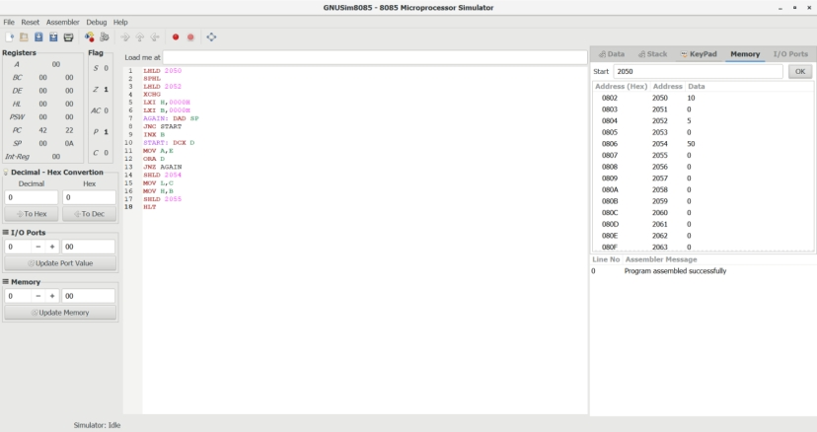

**RESULT:** Thus the program was executed successfully using 8085 processor simulator.